St Martin’s C of E Primary School
‘Inspiring children to be the best they can be’

Behaviour and Discipline
Policy

Agreed – Spring 2026
To be reviewed – Spring 2027

ST MARTIN’S C of E PRIMARY SCHOOL
BEHAVIOUR and DISCIPLINE POLICY
February 2026
GOVERNORS’ STATEMENT OF PRINCIPLES
The Governors of St Martin’s C of E Primary School believe that the school’s Behaviour and Discipline Policy should reflect the following principles:
- Staff, parents and governors should work together to create a safe learning environment in which children are secure and can grow in confidence to develop their talents. We all have high expectations of our children and expect them to work hard and behave well.
- Behaviour is well managed so that children are able to learn and teachers are able to teach.
- All pupils are supported to achieve their academic and social potential, and are provided with support to overcome any barriers to learning they may face.
- Respect – for each other, staff and other adults they may come across in the course of their school life and for their environment, is at the heart of the school’s ethos. Children will be encouraged to develop respect for a range of different views of our world.
- Children are encouraged to develop self-discipline and to take responsibility for their actions.
- All members of the school community have the right to
  - Feel safe and have a voice that will be heard
  - Learn and achieve to the best of their ability
  - Be treated with dignity and respect
  - Expect a clear Code of Conduct with accompanying rules and regulations which are well publicised, clear and consistently implemented.
- The school works in partnership with parents/carers and families and with other agencies who may be involved with a pupil.
- The school is fully inclusive and actively promotes equality of opportunity for all members of the school community regardless of race, religion, gender, sexual orientation or disability. The school will monitor the impact of all its policies and be alert to disproportionate impact on vulnerable groups.
- The school Behaviour and Discipline Policy should be based on the principles of positive behaviour management. Whilst sanctions may sometimes be necessary and appropriate wherever possible the school seeks to encourage the right behaviour rather than punishing the wrong.
The Behaviour and Discipline Policy should be read in conjunction with the following policies
- Anti Bullying
- Teaching and Learning
- SEND and Inclusion
- Equalities
- Child Protection and Safeguarding
- Responding to Parental Complaints
Staff at St Martin’s will work to regulate pupil behaviour and to impose disciplinary sanctions when pupils fail to observe the school’s rules, expectations and guidance. The school seeks to work in partnership with parents/carers at all times and expects them to support the school in creating a calm, ordered environment where teachers can teach and pupils can learn. All parents/carers sign the Home/School Agreement when their child starts at St Martin’s and in doing so agree to support the school in the implementation of the Behaviour and Discipline Policy.
School Rules

At St Martin’s we always try to
- Make the right choices
- Try our best
- Use our quiet voices
- Listen and follow instructions
- Look after each other and the school

These rules are used to inform the Class Rules which are developed by each class at the beginning of each school year. These rules have age appropriate ‘expectations’ which are discussed by the children, teacher and teaching assistants and then displayed in the classroom along with whole school rules that guide whole school behaviour.
PROMOTING GOOD BEHAVIOUR

At St Martin’s we believe that good behaviour needs to be modelled and taught. All staff (including support staff) have access to a range of continuous professional development (CPD) opportunities to develop their behaviour management strategies and skills. We encourage staff who are experiencing difficulties with individuals or groups of pupils to discuss and share good practice and ideas. We ensure that all supply teachers are provided with a summary of our behaviour policy and recommended strategies for promoting good behaviour.
(See Appendices).

We recognise the need for good behaviour to be ‘taught’ and ensure that appropriate behaviour is discussed within the curriculum (assemblies, Relationships, Sex and Health Education (RSHE) etc) as appropriate. We also ensure that pupils new to the school are fully inducted into the expectations of the school and that they understand the behaviour policy.

REWARDS

We believe that rewarding desired behaviour is more effective than sanctioning unacceptable behaviour. We take every opportunity to praise our children where they do the right thing. We are actively seeking to encourage ‘good learning behaviours’. The school has a range of rewards available:

- Class Reward Schemes – are designed by each class teacher in discussion with the children. Some are to reward individuals for positive behaviour and others are to reward groups of children for working together effectively. Examples that may be included, but not limited to are:

- Using the traffic light system – EYFS
- Dojos in KS1
- Individuals and/or groups may earn house points
- Individuals may earn ‘stickers’

- Celebration Assembly – certificates are awarded to children for a wide range of achievements including out of school achievements. We are particularly looking to reward ‘good learning behaviours’ and ‘good application of the school’s values’.

UNACCEPTABLE BEHAVIOUR
Includes:
- Causing deliberate physical injury to another child
- Causing deliberate physical injury to an adult
- Verbal abuse to an adult or to another child
- Making a racial, homophobic or sexist remark
- Swearing
- Persistent name calling or teasing
- Causing deliberate damage to property
- Refusing to follow instructions
- Disrupting the learning of the class (eg: by persistent calling out, wandering around the room, interfering with other children’s work)
- Inappropriate sexual behaviour/mimicking of sexual behaviour

CONSEQUENCES - in ascending order of severity

Teachers, teaching assistants and other paid staff with responsibility for children at St Martin’s have the legal power to discipline pupils whose behaviour is unacceptable, who break the school rules or who fail to follow a reasonable instruction. To allow for consistency teachers and support staff may refer to the Behaviour Continuum or the Behaviour Escalation Flowchart (see Appendices). If children make the wrong choice they can expect:

- A look from the teacher or adult leading the session or activity
- A verbal warning
- Time out away from the group with some constructive guidance (not outside the classroom/play area)
- To spend time in another class under the supervision of another teacher (appropriate work must be provided by the child’s class teacher)
- To be sent to talk to a Senior Leader, the Deputy Head or to one of the Headteacher, in which case their parents may be spoken to at the end of the school day
- To be excluded from the class for an agreed time (supervised by a Senior Leader)
- For their parents to be asked to come and meet with the Class Teacher, SENCo (Special Educational Needs Co-ordinator) Deputy Head or Headteacher
- To be excluded for a fixed period from St Martin’s
- To be permanently excluded from St Martin’s

When the children are at play, if they make the wrong choice they can expect:

- A look from the teacher or adult on duty
- A verbal warning
- Time out away from the group they are playing with (this time may be spent with the adult on duty or standing at the edge of the playground for a short period of reflection)
- Time inside the building under the supervision of a Senior Leader
- Time with the SENCo, a Senior Leader, Deputy Head or Headteacher
- That the incident will be recorded in our ‘Peaceful Playtimes’ file or using our CPOMs system
- An opportunity to discuss the incident and be given strategies/ideas to deal with a similar incident in the future

Some behaviour requires the immediate attention of the Deputy Head/Headteacher. In the absence of the Headteacher or Deputy Headteacher, these incidents will be referred to another Senior Leader or the SENCo.

These incidents include:
- Causing deliberate physical injury to another child
- Causing deliberate physical injury to an adult
- Verbal abuse to an adult or to another child
- Making a racial, homophobic or sexist remark
- Swearing
- Persistent, serious name calling or teasing
- Causing deliberate damage to property.
- Inappropriate sexual behaviour/mimicking of sexual behaviour

This type of behaviour is not acceptable in our school and parents will be contacted on these occasions. A CPOMs entry must be made by the reporting member of staff. This will be used to inform the Headteacher’s response and as the basis for feedback to teachers, LSAs and parents.

Although the school understands that very young children may need some support to fully understand the implications of some aspects of poor behaviour, some older children may benefit from a talk with the Community Police Officer.

Wherever there is an ongoing pattern of behaviour, which is causing concern, the school will carefully consider whether or not there are any related safeguarding issues. In these instances the Safeguarding and Child Protection Policy guidance will be followed. Parents will always be involved if we feel this would be a beneficial course of action for the child.

PUPILS REQUIRING ADDITIONAL SUPPORT

In the event of a child being unable to conform to the behavioural expectations of the school on more than an isolated occasion the school will consider the support needs of the child in more detail and children and their parents/carers can expect:

- for the Class Teacher, SENCo, Deputy Head or Headteacher to meet regularly with their parents/carers to monitor their behaviour
- for the SENCo to work with the class teacher and parents to draw up and implement an Individual Behaviour Plan
- for the school to engage the support of the Behaviour Support Services to advise on supporting the child
- for the school to consult the attached Educational Psychologist
- for the school to consider requesting a multi-agency assessment
- for the school to consider seeking a short-term placement at the PRU (Pupil Referral Unit)

REPORTING

Every class teacher has been trained to use our online reporting system.
Incidents will be recorded as ‘Behaviour’ or as ‘Significant Incidents’, depending on the nature of the poor behaviour.
A Positive Behaviour Support Plan (PBSP) is used for a very small number of children, who struggle routinely with managing their behaviour. These are set up by the SENCo and maintained by the teacher and are used to enable the school to develop a picture of the difficulties that a child is having in school and to allow for analysis of where/when/how etc. The PBSP considers the possible triggers and encourages a pro-active approach when managing behaviour concerns. All behaviour is a form of communication and the structure of a PBSP allows us to consider what the pupil is trying to convey and what support they need. Parents will always be aware and involved in any pupil who is on a PBSP.

RED CARDS

These are available throughout the school in every class base and in the play areas. They can be used for an adult to call for assistance in a range of different circumstances. A red card is asking for help immediately. These cards can be presented to the School Office, Deputy Headteacher or Headteacher. They can be used by staff who need assistance in removing a child from a difficult situation. They can be sent to the office via a Learning Support Assistant, a volunteer or a very sensible child.

ANTI BULLYING
St Martin’s School is determined that all pupils should feel safe at school and enjoy their education. A key feature of this is the strong stance taken against all forms of bullying. The school’s policy on anti-bullying can be found in the Anti-Bullying Policy.
USE OF REASONABLE FORCE
In accordance with the Education and Skills Act 2006 all staff may, on occasion, need to control or in extreme circumstances restrain a pupil to ensure that they do not:
- Hurt themselves
- Hurt somebody else
- Damage property
- Prejudice the good order of the school.
In the event of this requiring anything other than a light touch to the upper body a Significant Incident Report form will be completed and parents informed. If a pupil requires handling parents will be informed and a full debrief of pupil and staff involved held. A number of staff, in each phase, at St Martin’s have received training in ‘Positive Touch’.
For more information see DfE Guidance
https://www.gov.uk/government/publications/use-of-reasonable-force-in-schools
SCREENING AND SEARCHING
Pupils are discouraged from bringing things from home into school unless specifically requested to do so by a teacher (eg: for a class show and tell). The school cannot be responsible for anything that is brought in from home unless it is given to a member of staff or handed into the office at the start of the day (and collected at the end).
Staff reserve the right to check to see if pupils have unsuitable items on them, if they have reason to believe this might be so. Parents will always be spoken to in this event.
Staff reserve the right to take away items that are causing a disruption, either at break times or during lessons. Any items taken away from a child will be returned to the parent at the end of the school day.

CONFISCATION AND DISPOSAL
Staff will take items off a child if they bring anything unsuitable to school. Again, parents will be informed and the item will be returned to them at the earliest opportunity.
BEHAVIOUR OUT OF SCHOOL

Pupils are expected to uphold the reputation of the school whenever they are out of school whether they are taking part in an official school trip/outing or wearing their uniform to and from school. Pupils may be subject to sanctions if their behaviour brings the school into disrepute or has repercussions for the orderly running of the school.

St Martin’s staff cannot be responsible for pupil behaviour when they are out of school at the beginning or the end of the school day but will endeavour to investigate any incident which is reported to the school. The school will always cooperate with the Police in any investigation of incidents which are thought to involve our pupils.

ALLEGATIONS

Any allegation of misconduct against a member of staff will be taken seriously and referred to the Area Schools Officer (ASO) and Local Authority Designated Officer (LADO) and dealt with using the Surrey procedures (See Child Protection and Safeguarding Policy). Pastoral support will be offered to any individual against whom an allegation is made and the matter kept strictly confidential. If the allegation is against the Headteacher the Chair of Governors will be responsible for referring the matter. In the event of an allegation proving unfounded or malicious the matter will be referred to the Governors’ Discipline Committee for action. All staff appointed at St Martin’s have read the Government Guidance on Safer Working Practice in order to minimise the risk of allegations being made.

DETENTIONS

We do not detain pupils after school. Pupils may miss part of their play or lunchtime in order to make up work that has been missed through poor behaviour in class. We would expect parents to support this action, which will always consider the individual needs of the child in the decision making process.

PARENTS/CARER

St Martin’s School aims to work in partnership with parents/carers at all times. To do this parents/carers need to read and respond to communications from the school. Parents/carers are expected to support the school in upholding the school rules and creating an orderly climate for learning. They have the right to be informed promptly of any emerging difficulties their children present. In return parents/carers are expected to keep the school informed of any difficulties their child may be experiencing. Parents/carers have particular responsibilities in ensuring regular and punctual attendance at school and in ensuring their children are in the right place during any fixed period of exclusion. Parents/carers are expected to attend a Reintegration Interview following any period of fixed period exclusion. On admission to the school all pupils are required to sign the school’s Home School Agreement which can be found on the School’s website.

We recognise that sometimes parents/carers may feel that the school has not responded appropriately to concerns/difficulties that they or their child may have experienced. In those circumstances we will always listen to the concerns and endeavour to put matters right. In return we expect parents to recognise the professionalism of our staff and seek to resolve issues in a climate of mutual respect and support in the best interests of the children. If an issue cannot be resolved parents/carers can complain using the Complaints Procedure.

COMMUNICATING THIS POLICY

This policy is available in full on the school website and a hard copy can be requested from the School Office. Where necessary we will arrange to make it available in an accessible format to parents.
A summary of the policy is also available on the website and is given to parents/carers when their child is admitted to the school and on request. The Headteacher will remind parents/carers annually of the main features of the policy. Parents/carers will be involved in the review of this policy. A simplified version of our key school rules is prominently displayed in classrooms and around the school. Class teachers are encouraged to discuss these with children on a regular basis. They are also regularly mentioned in the school newsletters.

DATA

All data is logged on CPOMS and some on the school’s drive. Information about individual children may be collected as detailed above and will be retained in the child’s electronic file to inform future planning. Parents/carers have the right to request a copy of their child’s file (the school will make a charge for this).

The school collects a range of school level behaviour data including:

- Class Behaviour Book / Lunchtime Behaviour Book
- Significant Incident Reports & Sanctions
- Behaviour Logs for individual children (as necessary)
- Exclusions
- Attendance and punctuality

Data is analysed on a whole school basis by the Deputy Head, SENCo and Headteacher and is used to identify ‘hot spots’, monitor trends and performance against targets and to inform changes in policy and procedure. Data is also monitored to ensure the school meets its statutory duties with regard to the Equalities Policy. Individual children are not identified in school level data.

Data is presented to whole staff meetings, SLT meetings and to Governors in order to support the evaluation of the impact of the policy.

EXCLUSIONS

St Martin’s School is committed to using exclusion as an absolute last resort after all other sanctions have been exhausted. Permanent exclusion is extremely rare and is unlikely to be used for particularly vulnerable pupils. (eg: for those who are ‘Looked After’ by the Local Authority or who have EHCPs, where other alternatives may be sought.) The school seeks to use Fixed Period Exclusion extremely rarely, believing that rewarding poor behaviour with a ‘day off’ can be counter productive. Where exclusion is used the school conforms to the Surrey CC and DfE Guidance.
If pupils are excluded for a period of less than 5 days the school will provide work – it is the parent/carer’s responsibility to ensure the pupil completes the work and returns it to the school for marking (NB: parents can be fined if pupils are found in a public place during an exclusion). From Day 6 of an exclusion, pupils will be expected to attend another educational setting (to be specified at the time). In the event of a permanent exclusion the Local Authority will contact parents with details of the Day 6 provision.

Reintegration interviews are considered to be a vital part of the reintegration process and provide parents, the pupil and key school staff with an opportunity to reflect on what has happened and to plan any additional support which may be needed to ensure a pupil’s successful readmission. If parents do not attend a scheduled reintegration interview additional measures may be taken to facilitate their full participation in the process.

ROLES AND RESPONSIBILITIES

All staff play an important role in positive behaviour management and discipline. Class teachers will, in the first instance, manage the behaviour of the children in their class.

Class teachers are responsible for:
- Promoting a positive classroom environment where good behaviour is rewarded and modelled by the adults who work in the class
- Developing clear class rules for all children to follow
- Listening to parents’ and carers’ views about their child’s behaviour and needs
- Listening to children
- Creating a culture where children can express their concerns and worries
- Ensuring that work set is tailored to the ability of the child
- Ensuring that learning opportunities are active, relevant and purposeful
- Challenging low level misbehaviour
- Supporting the school’s Behaviour and Discipline Policy

Learning Support Assistants are responsible for:
- Promoting a positive classroom environment where good behaviour is rewarded and modelled by the adults who work in the class
- Listening to children
- Creating a culture where children can express their concerns and worries
- Supporting the learning of individual children or small groups of children under the direction of the teacher(s)
- Supporting the school’s Behaviour and Discipline Policy

Senior staff may be required to support individual members of staff when behaviour has become an issue. They may do this by applying consequences for individual children or by supporting staff to develop successful behaviour management strategies. Senior Leaders within the school will support all staff in creating and maintaining a positive learning environment.

REVIEW AND EVALUATION

This policy is subject to regular review and evaluation by:
Governors
Senior Leadership Team
Staff
Parents
Pupils

Chris Tuckett, Headteacher, 2026

APPENDICES

Strategies for promoting positive Classroom Management

- Mutual respect- politeness (greetings, saying thank you etc)
- High expectations of work and behaviour
- Build positive relationships – out of class as well as in class
- Listen to children
- Pay attention to beginning and endings – allow time to ensure children are clear about what they need to do and to reflect on what they have achieved (Learning Intentions and Success Criteria)
- Good and outstanding teaching encourages good behaviour – pay attention to planning, pitch and pace, interest and variety, differentiation, visual cues. Make learning exciting.
- Stimulating environment with motivating displays of student work – pay attention to layout of room so that all can see the interactive white board (IWB) etc.
- Ensure Code of Conduct, rewards and consequences are visible to all – use the rules as a buffer – depersonalise.
- Intervene early – do not let low level behaviours go unchallenged
- Give simple choices – expect children to ‘choose’ the right thing
- Praise children consistently. Actively catch them ‘being good.’
- Know the children well and understand their needs, SEND etc. Ensure you use strategies recommended in any professional reports and Behaviour Support Plans.
- Watch language, tone, posture, body language etc. Remain calm and cool at all times
- Plan the use of any additional adults to support children who need extra help to meet the lesson objectives
- Use of assessment for learning (AfL) strategies to encourage motivate and engage
- Ensure you always follow through on what you have said.
- Follow up – if something goes wrong in your lesson, even if SLT become involved, make yourself responsible.
- Be reflective and adjust your practice regularly to accommodate the needs of the children in your care.
- Seek advice from colleagues

St Martin’s Behaviour Continuum

Examples of behaviour | Possible response | Adults | Recording
LEVEL 1 – Class Teacher/ LSA level on escalation flowchart
- Calling out  - Out of seat  - Silly noises/faces  - Using equipment intentionally inappropriately/incorrectly (eg rocking on chair)  - Interrupting  - Low-level unwanted physical contact – e.g. poking  - Running inside the building  - Fidgeting (unless with ‘fidget tool’)  - Not following instructions  - Turning around and looking the wrong way  - Intentionally not being on task or completing learning  - Not being respectful (eg negative body language) | - Positive reinforcement  - A stern look from an adult  - Opportunity for child to think about their actions followed by a restorative conversation if necessary  - Opportunity for a ‘fresh start’  Over time:  - Inform parents if serious or repeated  - Record on CPOMS if serious or repeated  - Escalate on escalation flowchart if serious or repeated – use other adults for support/ advice/ escalation | Class Teacher & support staff | CPOMS (from ‘Inform Parents’ stage)
LEVEL 2 – Phase Leader/ ELSA/ SENCo/ FSW as appropriate
- Repeated pushing in the line  - Low-level name calling  - Play-fighting  - Refusal to complete work or follow instructions  - Carelessly breaking school’s or others’ property  - Negative verbal or physical response  - Inappropriate language including swearing (not directed)  - Unintentionally hurting someone as a result of another negative action or behaviour  - Spitting (not directed at a person)  - Low-level, intentionally hurting someone  - Loitering around school/deliberately being in the wrong place | Appropriate action(s) or consequence(s) from the list below that are appropriate and proportionate to the behaviour:  - Miss part of breaktime  - Restorative conversation  - Discreet discussion/phone call with parent from class teacher  - Time away in another classroom (or alternative, appropriate space) to continue learning – usually Phase Leader  - Right the wrong (eg apology)  - Support from ELSA – e.g. learning walk – attempt to understand the cause of the behaviour | Class Teacher & support staff  Phase Leader  ELSA  SENCo  Family Support Worker | CPOMS

LEVEL 3 – Deputy Headteacher (or Headteacher if deemed serious)
- Persistent, challenging, negative behaviour  - Persistent or serious rudeness / name calling  - Swearing at someone  - Graffiti / vandalism  - Stealing  - Intentionally hurting someone  - Serious, verbal or physical threat  - Spitting at someone  - Biting someone  - Deliberately breaking high-value property | Teacher to investigate the behaviour through questioning those involved. If it is determined to be both serious and deliberate, SLT should be involved.  Appropriate action(s) or consequence(s) from the list below that are appropriate and proportionate to the behaviour, in addition to teacher informing parent/carer:  - Miss whole of breaktime  - Restorative conversation  - Reduce access to playground  - Right the wrong (eg, clean up graffiti)  - Removal of a privilege (this cannot affect their access to a full curriculum)  - Inclusion team support and advice  - SLT involvement  - Discreet discussion/phone call to parent from class teacher  - SLT meeting with parent  - Behaviour agreement | Class teacher  Deputy Headteacher | CPOMS
LEVEL 4 – Headteacher (or Deputy Headteacher in Headteacher’s absence)
- Bullying, including online  - Sexual harassment & sexual violence  - Very serious challenge to adult  - Intentionally, seriously hurting someone  - Persistent, serious & deliberate misbehaviour  - Verbal / physical threat or behaviour towards a member of staff  - Discrimination (eg racism, homophobia, misogyny, against travellers) | Note: it is the teacher’s responsibility to provide full background info & context. SLT will then collaborate with class teacher to decide action(s) or consequence(s) from the list below that are appropriate and proportionate to the behaviour:  - Right the wrong/ restorative conversation  - SLT involvement  - Removal of a privilege (this cannot affect their access to a full curriculum)  - Meeting with parent/carer  - Possible external services involvement – eg STIP  - Inclusion team involvement  - Behaviour agreement  - Fixed term, internal suspension*  - Fixed term external suspension – TAMAT exclusion checklist to be used  - Reintegration support  - Referral to a Pupil Referral Unit (PRU)  - Permanent exclusion in extreme circumstances  *If internal suspension is not completed satisfactorily, it will be repeated. If it is still not completed satisfactorily, a fixed term external suspension will be applied. | Class teacher  Headteacher | CPOMS
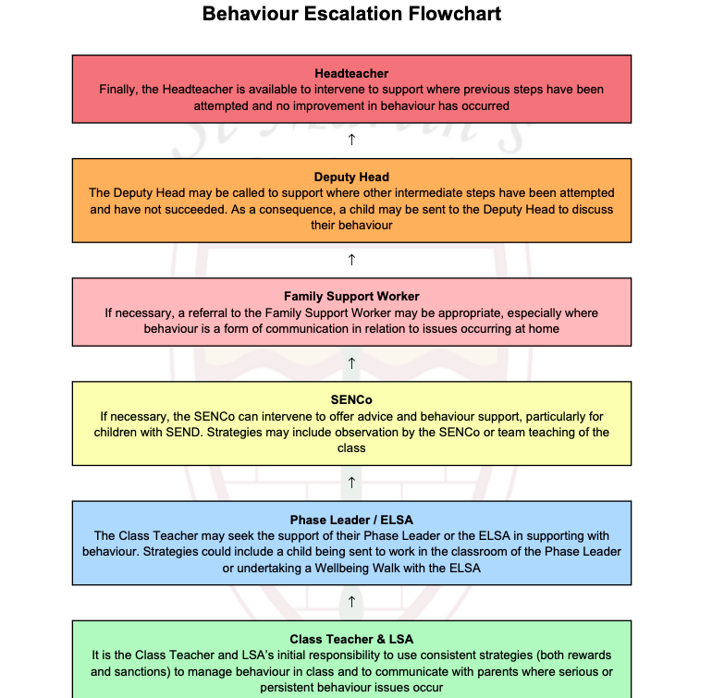

Positive Behaviour Support Plan

Pupil Name: |  | Year Group: | Class: |  | Date:
Key Relationships: |  |  | Skills/Talents/Hobbies:
Likes: |  |  | Dislikes:
Behaviours of concern:
Escalated behaviours that can impact the wellbeing or physical safety of the child or people around them.

Non-physical behaviours of concern:

Understand Behaviour |  |  | Identify the function
Before the Behaviour of concern | Setting conditions:  What makes the behaviour more likely to happen (not the cause or the trigger) such as particular people, places, activities. |  | What do you think they are trying to say?  Medical  Escape  Attention  Tangible  Sensory | Purpose:  Behaviours happen for a reason, consider why the behaviours of concern are happening, what is the reason behind it, is it to get away from something, gain attention/ support.
Before the Behaviour of concern | Triggers:  The things that happen just before the behaviour of concern occurs, for example saying no, a sudden change in routine, a particular demand.
Proactive Preventative Strategies |  |  | Proactive Developmental Strategies
Tools used to prevent or avoid behaviours of concern or dysregulation from occurring. |  |  | What skills do we need to teach? How and when will we teach them?
Reactive Strategies
Reactive strategies are what we do to respond to behaviours of concern when it happens to keep people safe and get things back to calm as soon as possible.

Capable Environments Checklist:
Capable environments are those that support a person effectively and provides the optimal setting to support positive interactions and opportunities.
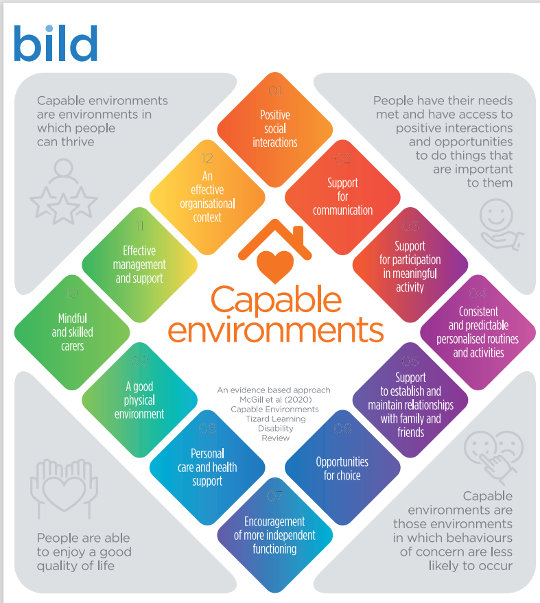
Review Date:

