|  |
| --- |
|  |
|  |
| **Special Educational Needs**  **and Disability Policy** |
| This Special Educational Needs and Disciplinary Policy  was approved and adopted by the Trust Board September 2025.  It will be reviewed: September 2026 |

**Special Educational Needs, Disability and Inclusion Policy**

St Martin’s believes that all pupils are entitled to an education that enables them to achieve their best, become confident individuals living fulfilling lives, and make a successful transition into adulthood.

The areas of need fall into four broad categories which are:

* Communication and Interaction
* Cognition and Learning
* Social, Emotional and Mental Health
* Sensory and Physical

For more information on these areas, please refer to our SEN information report.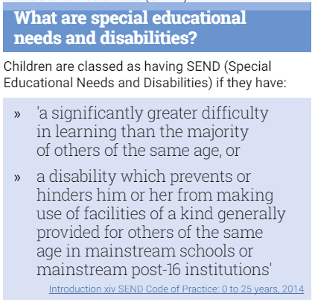

**How does St Martin’s identify pupils who may have SEND?**

All staff have a secure knowledge of pupil development. St Martin’s will monitor all children in the setting and use age-related expectations to guide the support offered.

Where a concern has arisen about a pupil’s progress, and during the process of monitoring the child, the school may decide to provide short term ***additional to or different from*** provision (e.g. small group intervention), with an aim to help the child narrow the gap quickly, so that further SEND provision is not needed. We ensure that staff have regular and up-to-date training in order to best meet the needs of the pupils they are working with.

If further support is required, we will discuss with parents/carers what provision can be provided within the setting.

**How are pupils with SEND supported at St. Martin’s?**

At St Martin’s we use the Assess/Plan/Do/Review cycle to ensure that pupils needs are appropriately met at every stage. 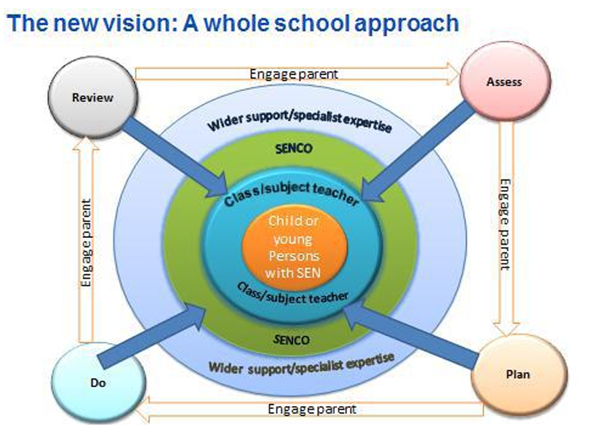

When we are caring for a pupil with SEND, we create a targeted plan (Pupil Passport) in collaboration with the pupil and class teacher and parents are informed. This plan details any additional provisions we will be making for the child and how we intend to meet their needs. This plan will be reviewed termly and shared with parents/carers. As an inclusive setting, we will provide suitable adaptations to ensure all children are able to access curriculum experiences. At all times, we will endeavour to develop children’s self-esteem, encourage the child’s confidence and increase their independence.

**How does St Martin’s work with parents/carers when a pupil has SEND?**

At St Martin’s, we work in close partnership with parents/carers and encourage an ongoing dialogue to better support their child.

When a plan has been created, parents/

carers will be encouraged to use similar

techniques at home as we do in the setting, to provide continuity for the child and to allow them to achieve their best outcomes.

**Will pupils with SEND have access to specialist support agencies and resources?**

Where appropriate, we will discuss with parents/carers the possibility of external agency involvement and we may encourage families to seek further advice, guidance and assessment.

We are part of TAMAT, which provides opportunities for sharing advice and expertise between SENDCos. In addition to this, where appropriate, we will seek advice from a range of professionals including: Educational

Psychologists, Specialist Teachers for Inclusive Practice (STIPs) Speech and Language, Occupational therapy, MindWorks, Mental Health Support Team and Woodlands Outreach. Any discussions with external professionals will be kept confidential at all times and the pupil will only be discussed with other agencies with permission from parents/carers.

How does St Martin’s support pupils through transitional periods?

At St Martin’s we recognise the importance of a smooth transition to ensure stability for the pupils. As such, we meet with previous settings to gather specific information about how best to support the pupils. We also meet with the pupil’s next setting in order to share our knowledge of how best to support the needs of the pupil moving forward. For more detailed information about transition, please refer to our SEN Information Report.

**How does St. Martin’s support pupils who are Looked After?**

At St Martin’s we have a Designated Teacher for Looked After and Previously Looked After Children: this is Alice Ingram. Alice is responsible for managing the provision of LAC and previously LAC to ensure that their needs are accounted for, regardless of whether they have SEND. This will involve liaising with school staff and outside agencies to implement and oversee specific provision in order to promote their educational achievement, wellbeing, and emotional development. The Designated Teacher has overall responsibility to ensure that high expectations of all aspects of the Looked After/Previously Looked After Child’s achievement are promoted by all school staff and agency professionals.

**What wellbeing support does St Martin’s offer to pupils?**

We support the emotional, mental and social development of children with SEND by providing extra pastoral support arrangements. We make provision for pupils’ spiritual, moral, social and cultural development. For more detailed information on available support, please refer to our SEN Information Report.

**Complaints procedure**

For complaints, please refer to the school’s complaints policy, available on the school website.